Classes:

1) Write a python class to convert an integer into a roman numeral and viceversa

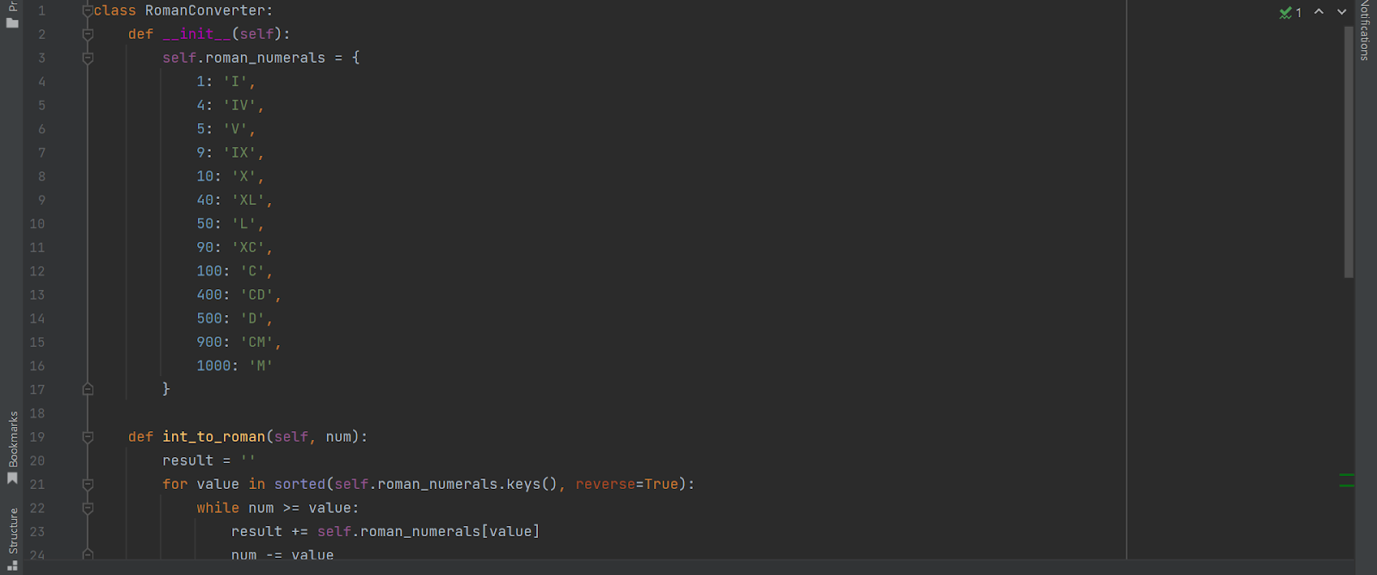

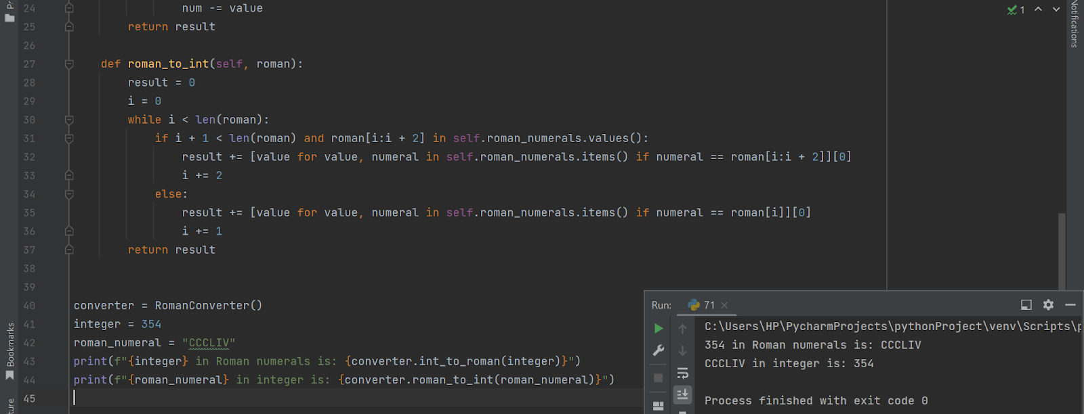

2) Write a Python class to find validity of a string of parentheses, '(', ')', '{', '}', '[' and ']. These brackets must be close in the correct order, for example "()" and "()[]{}" are valid but "[)", "({[)]" and "{{{" are invalid. 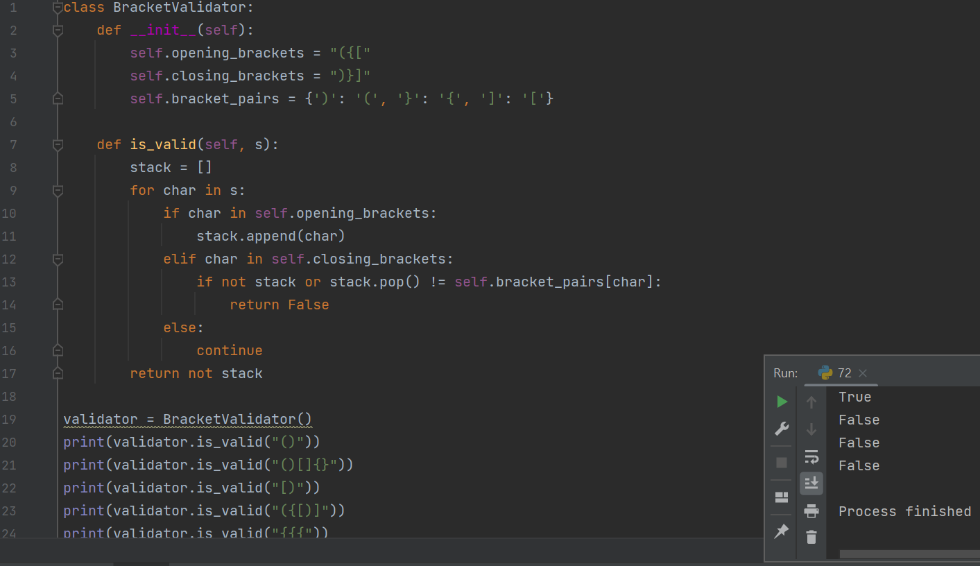

3) Write a Python class to get all possible unique subsets from a set of distinct integers Input : [4, 5, 6] Output : [[], [6], [5], [5, 6], [4], [4, 6], [4, 5], [4, 5, 6]]

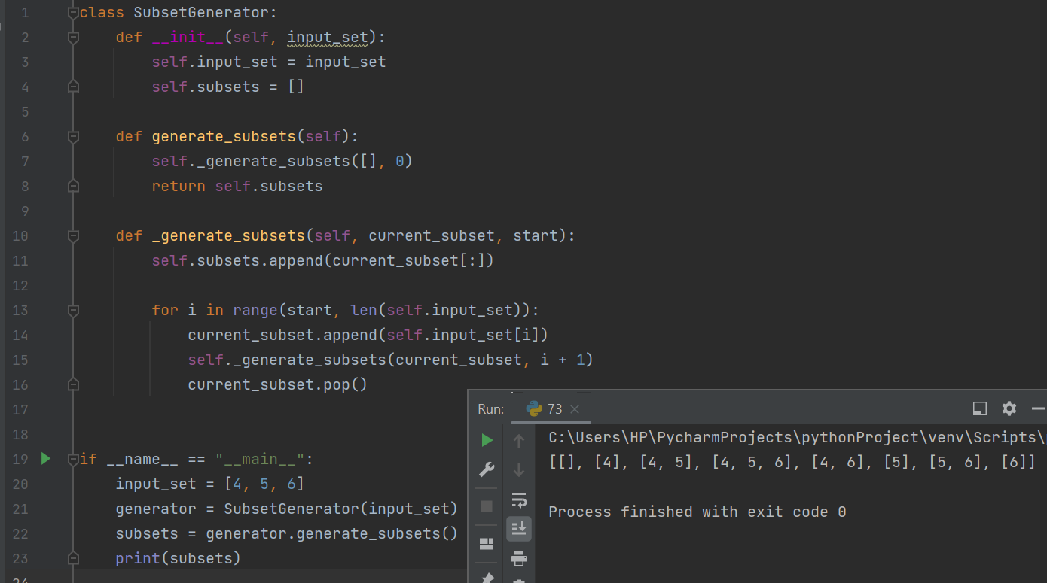

4) Write a Python class to find a pair of elements (indices of the two numbers) from a given array whose sum equals a specific target number. Note: There will be one solution for each input and do not use the same element twice. Input: numbers= [90, 20,10,40,50,60,70], target=50 Output: 3, 4 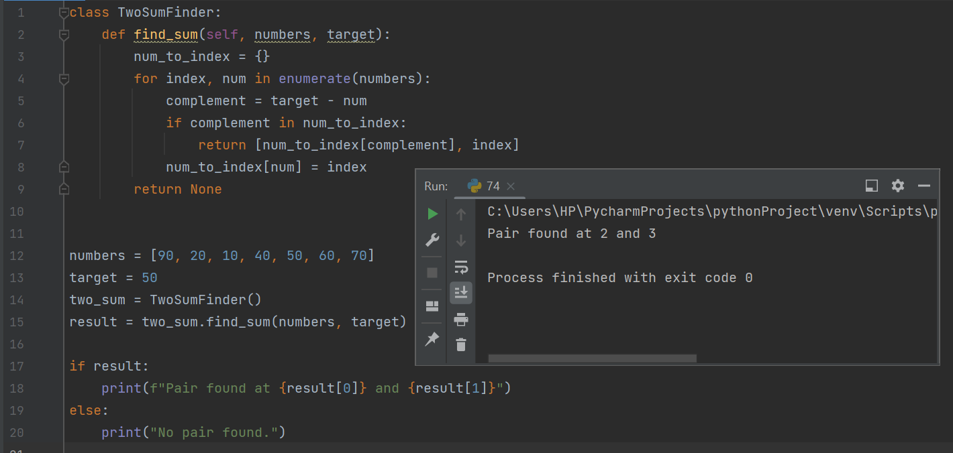

5) Write a Python class to find the three elements that sum to zero from a set of n real numbers. Input array : [-25, -10, -7, -3, 2, 4, 8, 10] Output : [[-10, 2, 8], [-7, -3, 10]]

6) Write a Python class to implement pow(x, n) 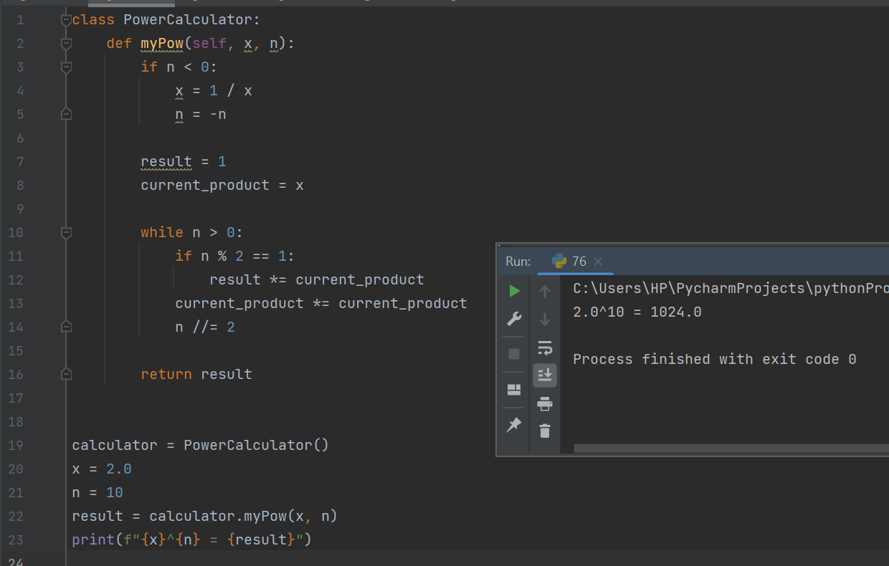

7) Write a Python class to reverse a string word by word.

Input string : 'hello .py' Expected Output : '.py hello' 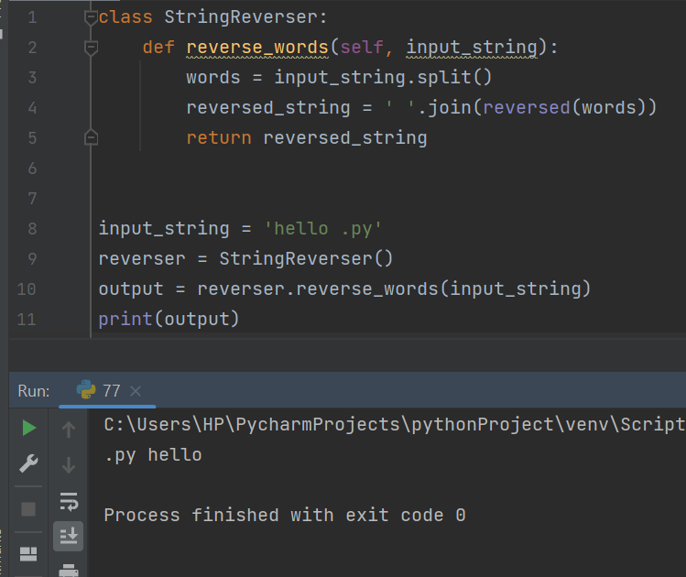

8) Write a python class which has 2 methods get_string and print_string. get_string takes a string from the user and print_string prints the string in reverse order 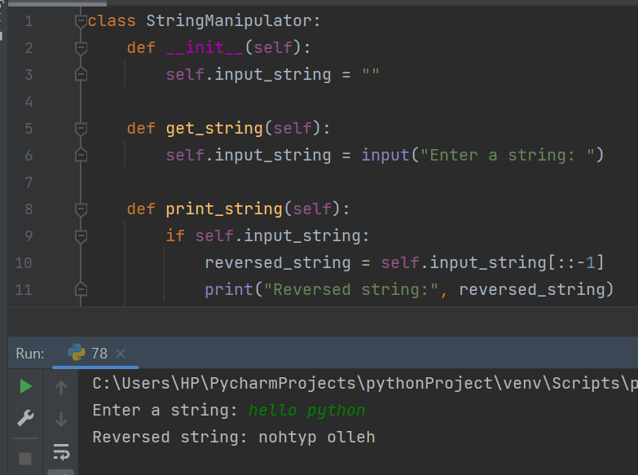

9) Write a Python class named Circle constructed by a radius and two methods which will compute the area and the perimeter of a circle.

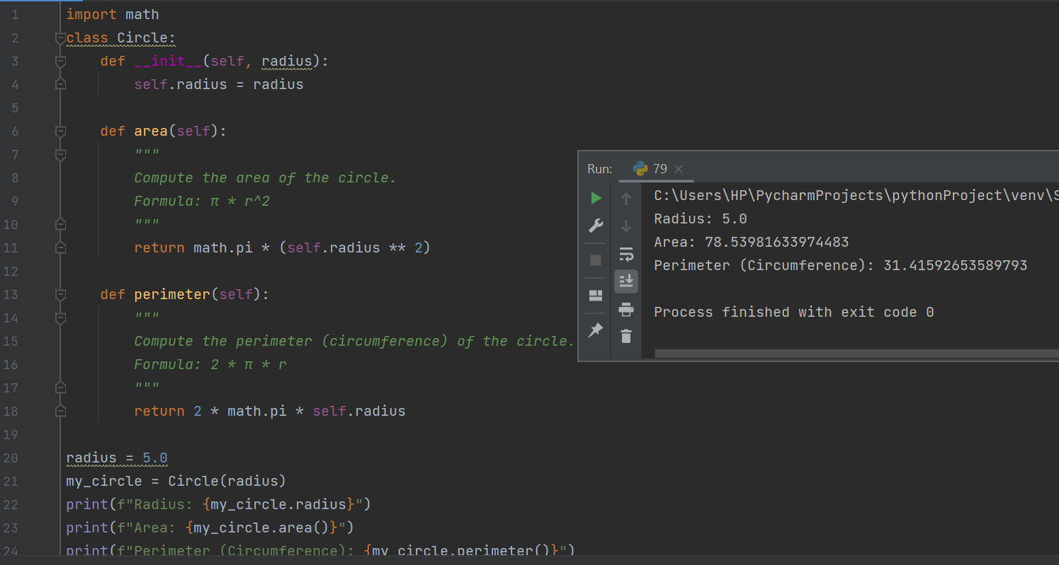

10) Write a Python program to get the class name of an instance in Python.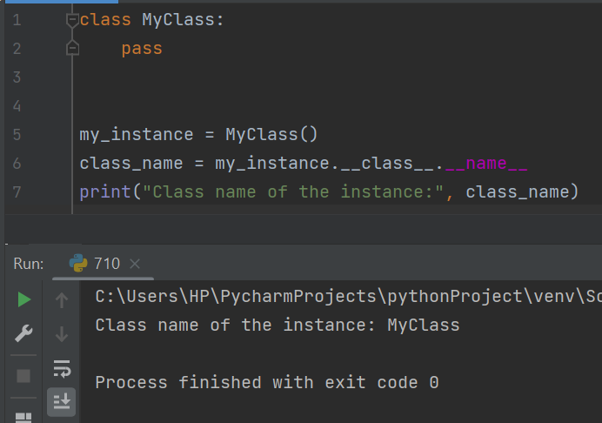

Lambda:

1) Write a Python program to create a lambda function that adds 15 to a given number passed in as an argument, also create a lambda function that multiplies argument x with argument y and print the result.

 Sample Output: 25 48 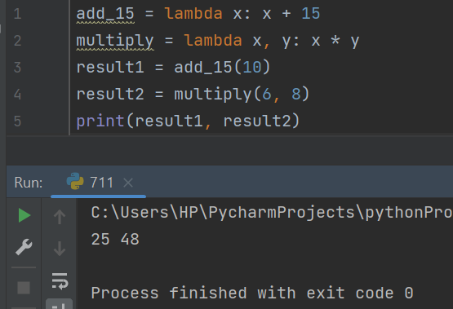

2) Write a Python program to sort a list of tuples using Lambda.

Original list of tuples: [('English', 88), ('Science', 90), ('Maths', 97), ('Social sciences', 82)]

Sorting the List of Tuples: [('Social sciences', 82), ('English', 88), ('Science', 90), ('Maths', 97)]

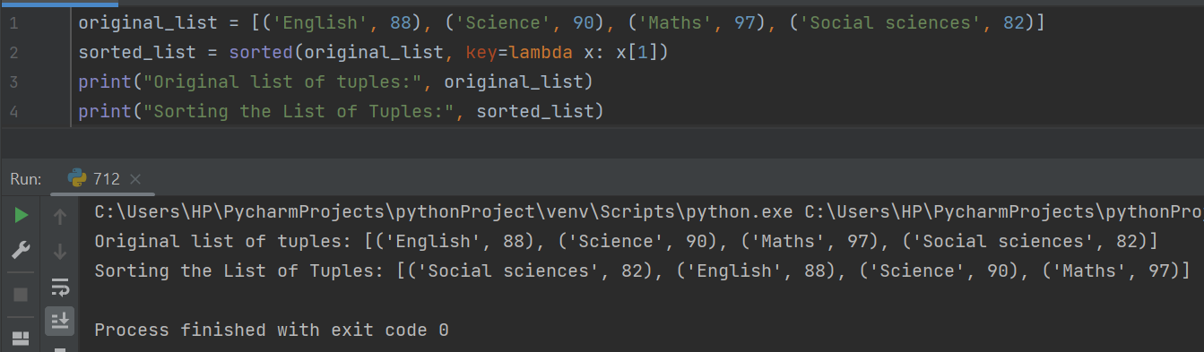

 3) Write a Python program to sort a list of dictionaries using Lambda.

Original list of dictionaries : [{'make': 'Nokia', 'model': 216, 'color': 'Black'}, {'make': 'Mi Max', 'model': '2', 'color': 'Gold'}, {'make': 'Samsung', 'model': 7, 'color': 'Blue'}]

Sorting the List of dictionaries : [{'make': 'Nokia', 'model': 216, 'color': 'Black'}, {'make': 'Samsung', 'model': 7, 'color': 'Blue'}, {'make': 'Mi Max', 'model': '2', 'color': 'Gold'}] 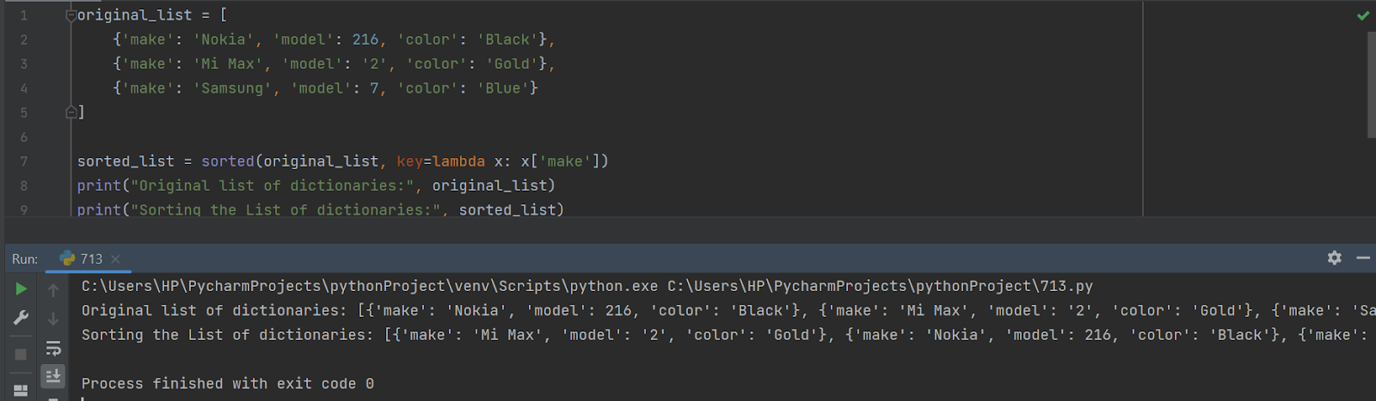

4) Write a Python program to find if a given string starts with a given character using Lambda.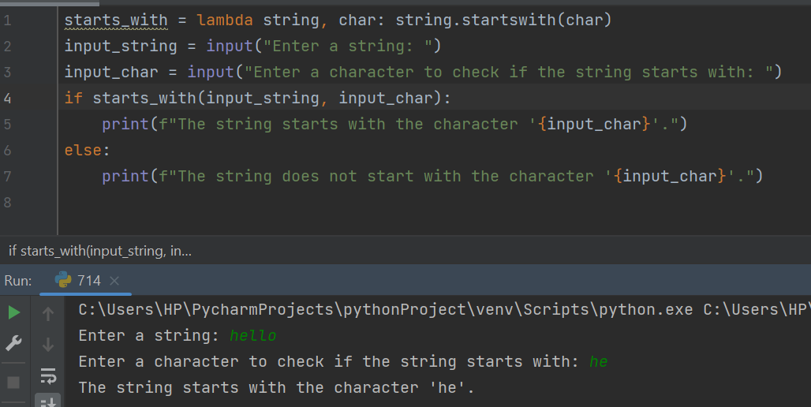

5) Write a Python program to check whether a given string is number or not using Lambda.

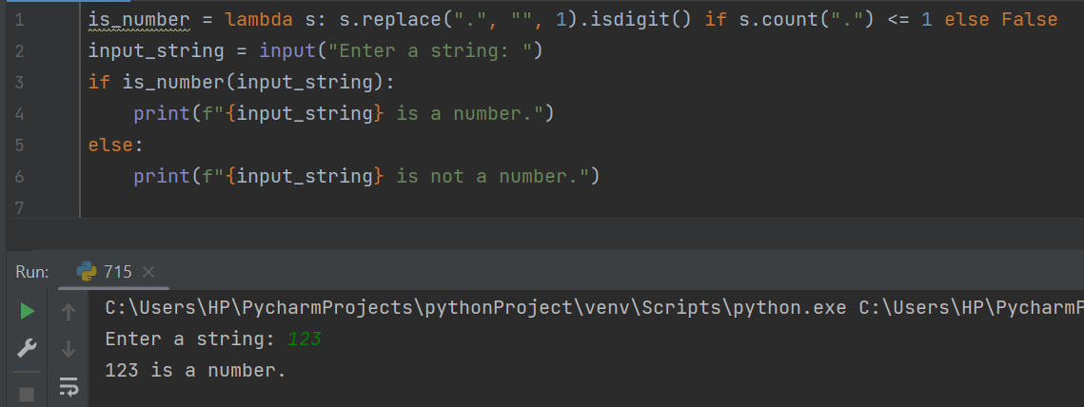

6)  Write a Python program to find numbers divisible by nineteen or thirteen from a list of numbers using Lambda

Orginal list: [19, 65, 57, 39, 152, 639, 121, 44, 90, 190]

Numbers of the above list divisible by nineteen or thirteen: [19, 65, 57, 39, 152, 190]

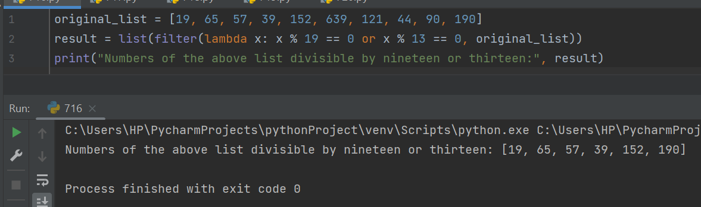

7) Write a Python program to sort a given matrix in ascending order according to the sum of its rows using lambda.

Original Matrix: [[1, 2, 3], [2, 4, 5], [1, 1, 1]]

Sort the said matrix in ascending order according to the sum of its rows [[1, 1, 1], [1, 2, 3], [2, 4, 5]]

 Original Matrix: [[1, 2, 3], [-2, 4, -5], [1, -1, 1]]

Sort the said matrix in ascending order according to the sum of its rows [[-2, 4, -5], [1, -1, 1], [1, 2, 3]] 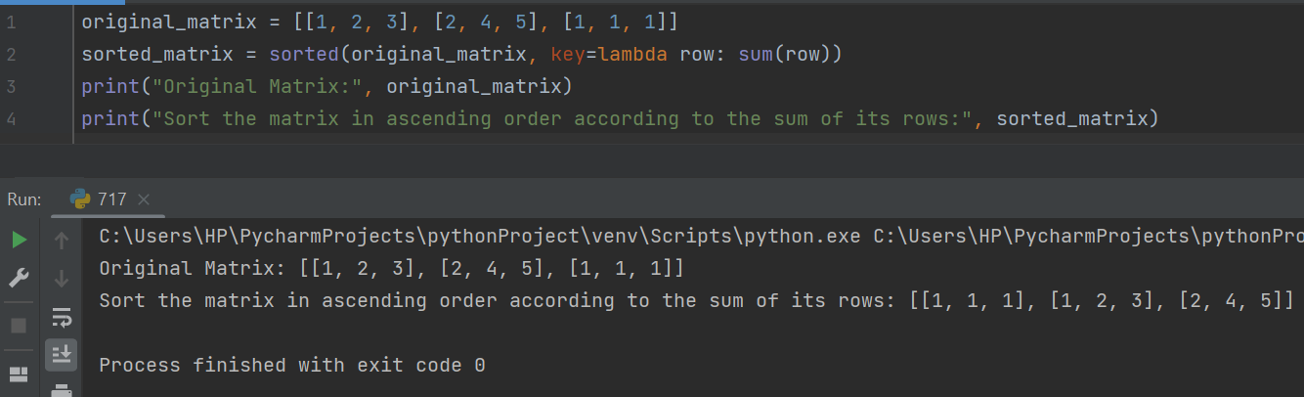

8) Write a Python program to check whether a given string contains a capital letter, a lower case letter, a number and a minimum length using lambda. Minimum length : 10 input string: PaceWisd0m o/p: valid string 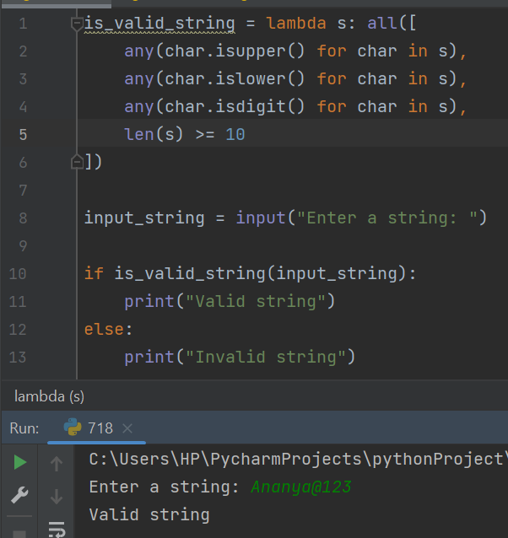

9) Write a Python program to find the elements of a given list of strings that contain specific substring using lambda.

Original list: ['red', 'black', 'white', 'green', 'orange']

Substring to search: ack Elements of the said list that contain specific substring: ['black'] Substring to search: abc Elements of the said list that contain specific substring: [] 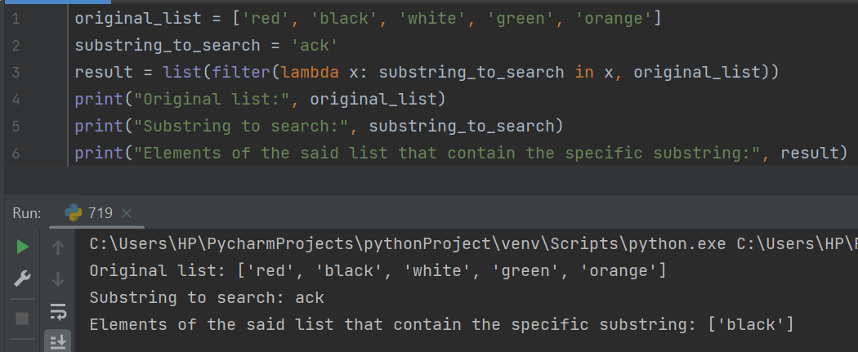

10) Write a Python program to sort a given mixed list of integers and strings using lambda. Numbers must be sorted before strings.

Original list: [19, 'red', 12, 'green', 'blue', 10, 'white', 'green', 1]

Sort the said mixed list of integers and strings: [1, 10, 12, 19, 'blue', 'green', 'green', 'red', 'white']

